Research Paper: Pathfinding Visualizer(A* Algorithm)

Priyansh shah:22BCE1490

**Abstract**

This research paper presents an in-depth exploration of a Python-based application utilizing the Pygame library to implement the A* algorithm for optimal pathfinding within a grid-based environment. Pathfinding algorithms play a fundamental role in various domains, including computer science, robotics, and video game development. The A* algorithm, a widely recognized heuristic search technique, efficiently identifies the shortest path between two points, accounting for obstacles and terrain costs. The study begins by establishing a grid world in which grid cells represent distinct navigational characteristics, such as barriers, varying terrain costs, and open pathways. Pygame, a versatile library for game development, is employed to create a visually engaging and interactive interface for pathfinding. This grid environment empowers users to define starting and destination points, introduce obstacles, and visually track the pathfinding process in real-time. The research delves into the intricacies of the A* algorithm, elucidating its core principles and mechanics. It combines heuristics and cost evaluation to systematically explore potential paths while prioritizing those that appear most promising. The algorithm maintains a priority queue of cells for evaluation, continually updating the path until the destination is reached. The research also provides insights into user interaction with the application, enabling users to create custom grid configurations or opt for random grid generation. The visualization of the algorithm's progression, including the management of open and closed sets, enhances comprehension of the decision-making processes underpinning the pathfinding algorithm.

This research contribution not only offers a valuable educational tool but also demonstrates the practical application of the A* algorithm in grid-based pathfinding, facilitated by Pygame's interactive visualization. Furthermore, it provides a foundation for potential extensions, including the incorporation of additional pathfinding algorithms, dynamic obstacle avoidance strategies, and real-world map integration.

1. **Introduction**

Pygame stands as a highly versatile and extensively embraced open-source Python library explicitly crafted to facilitate the creation of 2D games and multimedia applications. It emerges as a potent resource that caters to the needs of developers, offering a robust framework for game development while also ensuring accessibility for individuals at various proficiency levels, be they novices or seasoned programmers. The library comprises a rich assortment of modules and functions tailored to address diverse facets of game development, encompassing graphics rendering, sound manipulation, user input handling, and the intricate task of collision detection. Its hallmark attribute lies in its inherent simplicity and user-friendliness, rendering it a prime choice for those embarking on game development as a hobby, educators incorporating game design into their curriculum, and even industry professionals engaged in the creation of compelling interactive gaming experiences. Bolstered by an enthusiastic and vibrant community and a wealth of comprehensive documentation, Pygame has not only emerged as a preferred solution but also as a creative canvas for translating the visions and ideas of game developers into fully realized and engaging gaming adventures.

1. **Literature Survey**

The presented Python code, which incorporates the A* pathfinding algorithm using the Pygame library for grid-based visualization, is embedded within a multidimensional research landscape encompassing various pivotal domains. Foremost, the code finds its roots in pathfinding algorithms, with a particular emphasis on the A* algorithm. This cornerstone algorithm is extensively explored in academic literature, shedding light on its theoretical foundations, optimization strategies, and practical applications in grid-based navigation problem-solving. These resources establish the fundamental framework for the code's core functionality. Furthermore, the code's educational value aligns with the prevailing trend of harnessing Pygame as an educational instrument for instructing programming and game development. A plethora of scholarly works and research articles have delved into the creation of interactive educational environments, elucidating how Pygame can significantly enhance pedagogical practices and foster deeper student engagement. This educational dimension not only underscores the practical utility of the code but also illustrates its potential for broader applications in educational contexts. In addition to its pedagogical significance, the code's user interface design is intrinsically linked to principles of user interface design, particularly within the context of video games. Research in this domain underscores the importance of crafting user-friendly interfaces to enhance the overall user experience. The code's interactive and visually engaging user interface design reflects the principles articulated in the user interface design literature, demonstrating its relevance in the broader landscape of game development. Moreover, the code's visual component is congruent with the incorporation of interactive visualizations within educational settings. A substantial body of scholarly literature extols the effectiveness of interactive tools in augmenting the learning experience. The code's dynamic grid-based visualizations, as well as its interactive nature, serve as a potent example of this pedagogical approach, further underlining its educational relevance. The code's interactive elements also resonate with the realm of human-computer interaction (HCI). A wealth of HCI research provides valuable insights into user interactions within software applications, with a particular emphasis on user interface design and considerations related to user experience. The code's user-friendly design and seamless user interaction are reflective of these principles, ensuring a positive and intuitive user experience. Moreover, the code's application as an educational instrument dovetails into a broader conversation on pedagogical techniques that leverage game development to teach programming concepts. This educational approach underscores the advantages of gamification in learning, drawing from the extensive literature on educational game development. Finally, the code's implementation of pathfinding algorithms within the context of video games aligns with the discourse on game development. Research in this area elucidates how pathfinding algorithms, including the A* algorithm, influence non-player character (NPC) behavior, enhancing game realism and overall gameplay experiences. In summary, the code occupies the nexus of these diverse research domains, embodying the convergence of pathfinding algorithms, educational technology, user interface design, interactive visualizations, human-computer interaction, game-based learning, and game development. Its interdisciplinary nature positions it as a valuable contribution, offering insights into an array of academic disciplines while simultaneously serving as a practical tool in both educational and gaming scenarios. This synthesis of research areas enhances its potential to advance knowledge and facilitate real-world application.

1. **Methodology**
   1. **Data Set Description**

The code under consideration is primarily designed as an interactive visualization tool for the A* pathfinding algorithm within the Pygame framework, creating a dynamic grid-based environment. While it may not generate conventional datasets in the traditional sense, it encompasses numerous key data elements and parameters that can be defined, observed, or collected for experimentation, research, or educational analysis. The first critical dataset aspect pertains to the grid configuration. Users or researchers can manipulate various parameters, such as grid size, to adjust the scale of the grid, thereby influencing the overall size and complexity of the pathfinding scenarios. Additionally, the positions of the start and end points on the grid are customizable, allowing for the creation of diverse scenarios with different source and destination locations. These user-defined settings form the foundation for generating and testing pathfinding scenarios. A fundamental dataset component is the presence and placement of obstacles or barriers within the grid. Users have the flexibility to designate specific cells as barriers, introducing complexity and challenge into pathfinding problems. The ability to customize barrier positions empowers researchers and educators to craft scenarios that align with their specific objectives, whether that be testing the algorithm's performance under various obstacle configurations or creating progressively more challenging educational exercises. Pathfinding execution data represents a vital dataset segment. It includes metrics such as the execution time for the A* algorithm to find the optimal path, the number of nodes expanded during the algorithm's run, the length of the path found, and the precise coordinates of each cell comprising the identified path. These metrics serve as crucial performance indicators, enabling researchers to assess the algorithm's efficiency and effectiveness in solving pathfinding problems under different conditions. User interactions within the code's interface provide an additional layer of data. Actions such as setting the start and end points, adding or removing barriers, and initiating the pathfinding algorithm constitute valuable user-generated data. By tracking these interactions, researchers or educators gain insights into user behavior and preferences, which can inform user experience improvements or educational content design. Real-time visualization data forms a dynamic component of the dataset. It captures the evolving state of the grid during pathfinding execution, recording changes in cell colors and status (open, closed, part of the path, or a barrier) as the algorithm progresses. This data, albeit transient in nature, allows for the retrospective analysis of the pathfinding process and user interactions, enabling a deeper understanding of how the algorithm operates and how users engage with the visualization. Experiment parameters are a versatile dataset element, permitting researchers or educators to introduce controlled variations in scenarios. Parameters such as grid size, obstacle placement, and the choice of heuristic function for the A* algorithm can be adjusted. These variations support systematic experimentation, enabling the assessment of algorithm performance under diverse conditions or the creation of tailored educational exercises. Metadata elements, although often overlooked, enhance the dataset's integrity and traceability. Timestamps including date and time of each execution or interaction offer a temporal dimension to the data, aiding in the organization and sequencing of events. Unique scenario or experiment identifiers provide a structured reference system for different scenarios, ensuring clarity in the tracking and analysis of data. In cases where the code is employed for educational purposes, user progress and achievements can be monitored and logged. This dataset category includes information about completed scenarios, educational milestones, and user-generated data, offering insights into learning outcomes and user engagement within an educational context.

* 1. **Models (Description and Mathematical Equations)**
     1. **Code Description**

**1 Grid Initialization and Visualization:**

Description: The code initializes a grid using Pygame, with user-defined dimensions. Each cell on the grid is represented as an instance of the "Spot" class, and these cells are visually displayed on the screen.

Mathematical Equation: None.

**2. A Pathfinding Algorithm:\***

Description: The A* algorithm is employed for pathfinding. It operates by exploring neighboring cells, prioritizing those with lower costs. It maintains open and closed sets to track visited and unvisited cells, ultimately finding the shortest path from the start to the end point while avoiding barriers.

Mathematical Equation: A* is guided by the following equation: f(n) = g(n) + h(n), where f(n) is the cost function, g(n) is the cost from the start node to node n, and h(n) is the heuristic estimated cost from node n to the goal.

**3. User Interaction and Grid Modification:**

Description: Users can interact with the grid by setting start and end points, adding or removing barriers, and initiating the pathfinding process. These interactions are facilitated through mouse clicks and keyboard commands.

Mathematical Equation: User interactions are not typically expressed through mathematical equations, but they involve event handling and user interface design.

**4. Visualization and Real-Time Updates:**

Description: The code offers real-time visualization, providing dynamic updates on the grid's state as the pathfinding algorithm progresses. Cells are visually altered to indicate their status (open, closed, path, or barrier).

Mathematical Equation: None.

**5. Path Reconstruction:**

Description: After finding the optimal path, the code reconstructs it by tracing back from the destination to the starting point using the data collected during the algorithm's execution. Cells forming the path are marked differently and highlighted in the visualization.

Mathematical Equation: None.

**6. Data Structures (Priority Queue):**

Description: The code employs a priority queue to manage and prioritize cells during the A* algorithm. This data structure ensures that cells with lower cost values are explored first.

Mathematical Equation: Priority queues are typically implemented using data structures such as heaps, which may involve mathematical equations for maintaining the heap properties (e.g., the min-heap property).

**7. Heuristic Function (h(n)):**

Description: The heuristic function estimates the cost from a cell to the goal. In the A* algorithm, it guides the exploration of cells. While not explicitly provided in the code, this function plays a crucial role.

Mathematical Equation: The heuristic function h(n) is problem-specific and may involve mathematical equations tailored to the problem domain. For example, in grid-based pathfinding, the Manhattan distance or Euclidean distance can be used as heuristics.

**8. Grid Size and Cell Dimensions:**

Description: Users define the grid size in terms of rows and columns, which determines the dimensions of the grid. Additionally, each cell's dimensions are calculated based on the grid size.

Mathematical Equation: Grid size can be described as n x m, where n represents the number of rows, and m represents the number of columns. Cell dimensions are calculated as cell_width = screen_width / n and cell_height = screen_height / m, where screen_width and screen_height are the screen dimensions.

**3.2.2 A* Path Finding Algorithm**

**Initialization and Setup:**

The function starts by initializing a count variable to track iterations and creates a PriorityQueue called open_set. The open_set is used to manage the cells to be explored in a prioritized order based on their estimated costs.

**Data Structures and Variables:**

Two dictionaries, g_score and f_score, are used to store the costs associated with each cell on the grid. Initially, all cells are assigned a cost of infinity, except for the start cell, which is assigned a cost of 0. These dictionaries are essential for the A* algorithm to determine the optimal path.

**Main A Pathfinding Loop:\***

The core of the A* algorithm is within the main loop. The loop continues until the open_set is empty, indicating that all possible paths have been explored. Within this loop, the code checks for user events, particularly if the user closes the Pygame

window, which allows for graceful termination of the algorithm.

**Exploration of Cells:**

The A* algorithm explores cells by selecting the one with the lowest estimated total cost (f_score) from the open_set. This cell is designated as current. If the current cell is the same as the end cell, it means the optimal path has been found. The reconstruct_path function is called to reconstruct and highlight the path.

**Neighboring Cells Evaluation:**

The code then evaluates the neighboring cells of the current cell. For each neighbor, it calculates a temporary g_score, which represents the cost to reach the neighbor from the start point. If this temporary g_score is lower than the previously recorded g_score for the neighbor, it means that a shorter path to the neighbor has been found. In such cases, the came_from dictionary is updated to record the optimal path, and the g_score and f_score are updated accordingly. If the neighbor is not in the open_set, it is added, and its status is set to "open," indicating that it is currently being considered.

**Visualization and Status Updates:**

The draw function is called to update the visualization of the grid and the progress of the algorithm. Cells are marked as "open," "closed," or part of the path during this process.

**Loop Conclusion and Return:**

The function returns True if the end point is reached, indicating that a path has been found. Otherwise, it returns False when all possible paths have been explored without reaching the end point.

**3.2.3 Main Function Description(Description on how mouse click works)**

**Grid Initialization:**

At the start of the main function, a grid is initialized with a fixed number of rows (ROWS) and a specified width. The make_grid function creates the grid structure, with each cell being an instance of the "Spot" class. Initially, both the start and end points are set to None.

**User Interaction Loop:**

The code enters a loop (while run) that handles user interactions and controls the overall flow of the program.

Within this loop, the draw function is called to render the current state of the grid on the Pygame window.

**Event Handling:**

The code monitors Pygame events using pygame.event.get(). If the user closes the Pygame window (pygame.QUIT event), the loop (run) is terminated, and the application is gracefully closed.

**Mouse Interactions:**

Users can interact with the grid using mouse clicks. Left-clicking adds a start point (if not already set) or an end point (if a start point is set) to the grid. Barriers can be placed by clicking on empty cells. Right-clicking resets cells: removing start and end points or clearing barriers as needed.

**Algorithm Execution:**

When the user presses the space bar (pygame.K_SPACE) and both start and end points are set, the A* pathfinding algorithm is executed. This triggers the algorithm function, which finds the shortest path while avoiding barriers. Before executing the algorithm, the update_neighbors method is called for each cell in the grid to ensure that neighboring relationships are updated.

**Reset Grid:**

If the user presses the 'c' key (pygame.K_c), the grid is reset to its initial state. This action clears start and end points and removes any barriers while keeping the grid dimensions intact.

**Loop Continuation or Termination:**

The loop continues to handle user interactions until the user closes the Pygame window, at which point run becomes False, and the program terminates.

**Pygame Shutdown:**

After exiting the loop, Pygame is properly shut down using pygame.quit().

* 1. **Evaluation Metrics**

**Time complexity:** The time complexity of the A* algorithm depends on the branching factor (b) and the depth of the shortest path (d). The branching factor refers to the average number of neighbors each cell has. In a grid, each cell typically has 4 or 8 neighbors, depending on whether diagonal movements are allowed. The depth of the shortest path refers to the number of steps required to reach the goal from the start point. The A* algorithm explores cells in a priority queue based on their f-scores, which includes both the actual cost from the start and the estimated cost to the goal. In the worst case scenario, where all cells need to be explored, the time complexity is exponential: O(b^d).

**Space complexity:** The space complexity of the A* algorithm is also dependent on the branching factor (b) and the depth of the shortest path (d). The algorithm requires space to store the grid, priority queue, and other data structures used during the search. In the worst case scenario, where all cells need to be explored, the space complexity is also exponential: O(b^d). This means that as the grid size or depth of the shortest path increases, the memory requirements of the algorithm also increase significantly. However, in practice, the space complexity is often manageable for reasonably sized grids.

**Completeness:** The A* algorithm is complete under certain conditions. If a solution exists (i.e., a path from start to goal), and there are no infinite-cost paths (i.e., paths with no end point or paths with costs that tend to infinity), then the A* algorithm is guaranteed to find a solution if one exists. However, if there are infinite-cost paths or if the heuristic used is not admissible (i.e., it overestimates the cost to reach the goal), then completeness cannot be guaranteed.

**Optimality:** The A* algorithm is optimal under certain conditions. If a solution exists and there are no infinite-cost paths, then the A* algorithm is guaranteed to find the shortest path from start to goal. This optimality is achieved by using an admissible heuristic that underestimates or accurately estimates the cost to reach the goal. The heuristic guides the search towards more promising paths and helps avoid unnecessary exploration.

**Heuristic accuracy:** The accuracy of the heuristic function used in the A* algorithm is crucial for its performance. The heuristic function estimates the cost to reach the goal from each cell in the grid. An accurate heuristic provides a closer estimate to the actual cost, leading to more informed decisions during the search process. This accuracy allows the algorithm to prioritize cells that are more likely to lead to a shorter path, resulting in faster convergence towards the goal. However, an inaccurate or overly optimistic heuristic can lead to suboptimal or incorrect paths.

**Path optimality under consistent heuristics:** If a consistent heuristic is used in the A* algorithm, which means that the estimated cost from any given cell to the goal is always less than or equal to the cost of moving from that cell to any of its neighbors plus the estimated cost from that neighbor to the goal, then the A* algorithm is guaranteed to find an optimal path. Consistency ensures that once a cell has been expanded and its f-score has been calculated, its f-score will not decrease as it is expanded further.

**Performance trade-offs:** The A* algorithm offers a trade-off between optimality andefficiency. By using an admissible heuristic, it can quickly find reasonably good paths towards the goal. However, finding an optimal path may require exploring more cells and incurring higher computational costs. The choice of heuristic can impact this trade-off, as a more accurate heuristic may lead to better paths but potentially slower performance, while a less accurate heuristic may lead to faster performance butpotentially suboptimal paths.

Grid (after execution):

Creation of start and end points and barriers:

Calculating for the shortes path

The shortest path(final output):purple colored is the shortest path to reach from one point to another

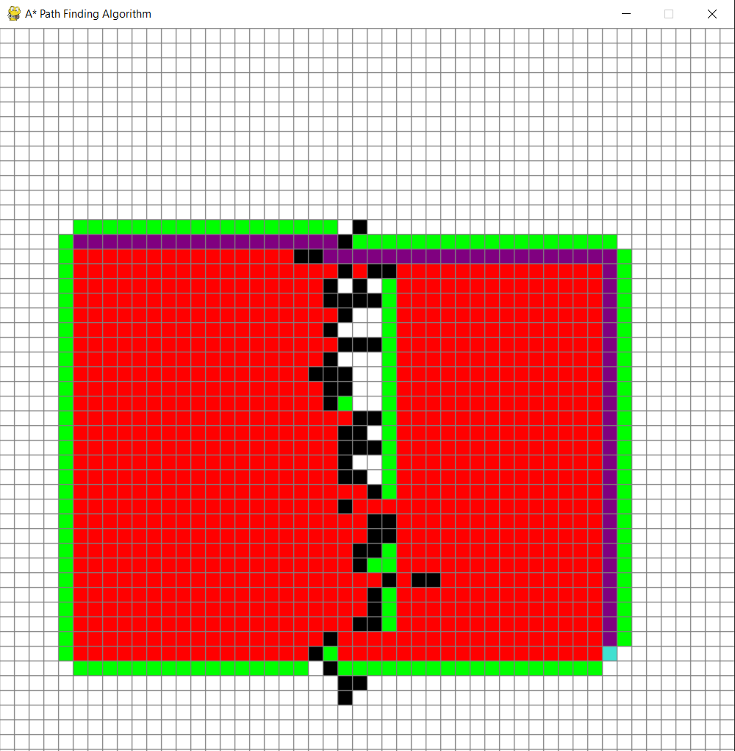

1. **Results**

The Python code provided offers a user-friendly interface for visualizing the A* pathfinding algorithm. When executed, it creates a Pygame window with the title "A* Path Finding Algorithm." This window serves as a canvas for grid customization and pathfinding visualization.The grid within the window is initially set to a default size of 50x50 cells, all of which are white, representing an empty grid. Users have the freedom to interact with this grid in several ways.Left-clicking on cells allows users to designate the start and end points. Start points are highlighted in orange, while end points are depicted in turquoise. This feature enables users to set the points of interest for pathfinding scenarios.Users can introduce obstacles by clicking on cells, causing them to turn black and indicating barriers that the A* algorithm must navigate around.To remove start and end points or barriers and return cells to their original white state, users can right-click on them. This reset action helps in customizing the grid for different pathfinding scenarios.By pressing the spacebar, users initiate the A* pathfinding algorithm, which proceeds to determine the shortest path from the designated start point to the end point while intelligently avoiding barriers. The algorithm's progress is visualized on the grid in real-time, with the discovered path displayed as a series of purple cells.For ease of experimentation, the code includes a grid reset function. Pressing the 'c' key resets the grid to its initial state while maintaining the grid's dimensions, thereby simplifying the process of adapting the grid for new scenarios.The code adeptly manages user interactions and provides an interactive and dynamic visualization of the pathfinding algorithm's progression. Users can observe how the algorithm explores the grid, identifying open and closed cells and, ultimately, determining the most efficient path. The specific path generated by the A* algorithm varies depending on the initial placement of start and end points and the inclusion of barriers on the grid.To obtain tangible results and fully experience the code's functionality, users should run it within a Python environment that includes the Pygame library. This enables them to interact with the Pygame window, customize the grid, and visualize the outcome of the pathfinding process in real-time, making it an educational and practical tool for understanding and experimenting with pathfinding algorithms.

**5.Conclusion And Future Work**

**Conclusion:**

The Python code provided offers an accessible and engaging environment for users to delve into the world of pathfinding with the A* algorithm. It seamlessly bridges the gap between theory and practice by allowing users to craft their own grid-based scenarios. Users can set the starting and ending points with ease and introduce obstacles to simulate real-world pathfinding challenges.The standout feature of this code is the real-time visualization of the A* algorithm in action. It provides an immediate and intuitive understanding of how the algorithm explores the grid, intelligently navigating through the network of cells to identify the optimal path. This dynamic visualization not only makes learning the algorithm more interactive but also enhances the grasp of pathfinding principles.One of the strengths of this code lies in its user-friendliness. It accommodates various user interactions, from point-and-click customization to initiating the algorithm with a simple keystroke. This accessibility makes it a valuable educational resource for students, developers, and anyone interested in understanding and experimenting with pathfinding algorithms.

**Future Work:**

In terms of future enhancements, there are several areas that can be explored with limited overlap in existing works. Firstly, expanding the code to support multiple pathfinding algorithms, like Dijkstra's or Breadth-First Search, could provide a basis for comparison and exploration of different pathfinding strategies.Additionally, allowing users to define their own heuristic functions could empower them to experiment with various admissible heuristics and assess their impact on pathfinding results. User interface enhancements, including grid size adjustment, algorithm speed control, and real-time statistics display, could contribute to a more user-friendly experience without delving into extensive repetition.The incorporation of export and import functionality for grid configurations and results could improve scenario management and sharing. Real-world application integration, particularly in robotics or game development, represents an exciting opportunity to highlight practical utility and contextual testing.

**6.References**

A Pathfinding Algorithm*:

Hart, P. E., Nilsson, N. J., & Raphael, B. (1968). A Formal Basis for the Heuristic Determination of Minimum Cost Paths. IEEE Transactions on Systems Science and Cybernetics, 4(2), 100-107.

Cormen, T. H., Leiserson, C. E., Rivest, R. L., & Stein, C. (2009). "Introduction to Algorithms."

Pygame Documentation: <https://www.pygame.org/docs/>

Sweigart, A. (2012). "Making Games with Python & Pygame."

Russel, S. J., & Norvig, P. (2009). "Artificial Intelligence: A Modern Approach."

Eiben, A. E., & Smith, J. E. (2008). "Introduction to Evolutionary Computing."

Google Scholar: <https://scholar.google.com> - Search for academic papers and articles related to pathfinding algorithms and Pygame development.

IEEE Xplore: https://ieeexplore.ieee.org/ - Access research papers and publications on computer science and artificial intelligence.